Working Paper Series

Working Paper Number 2

Collaborative research for sustainability: an inside-out design manifesto
G. Burford

CASIC, Keele University, October 2015
Library Catalogue Reference: CWPS0002

Published by: Community Animation and Social Innovation Centre (CASIC)
Faculty of Humanities and Social Sciences, Keele University,
Keele, Staffordshire, ST5 5BG
Tel: +44 (0)1782 732000
Email: support.casic@keele.ac.uk or for information on the
Working Papers Series l.hamilton@keele.ac.uk
Web: www.keele.ac.uk/casic

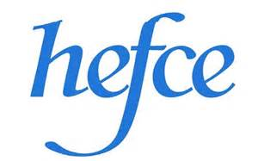

COLLABORATIVE RESEARCH FOR SUSTAINABILITY:
AN INSIDE-OUT DESIGN MANIFESTO

G. Burford, Values and Sustainability Research Group, University of Brighton

Abstract
The term ‘inside-out design’ is coined here to refer to a twofold process of (i) ‘starting from the inside’, i.e. reflecting on one’s own core values and priorities at the start of a project or activity; and then (ii) ‘going outside’, by engaging in genuine dialogues with other people about their values and priorities and by interrelating in more meaningful ways with the more-than-human community. Inside-out design is proposed as a means of removing the assumptions of superiority and inferiority associated with traditional discourses of ‘bottom-up’ versus ‘top-down’, not only in sustainability work, but also in other arenas. This working paper blends traditional academic prose with visual art and poetry, both as a deliberate attempt to provoke an affective response that lingers in the reader’s memory, and as a challenge to some of the conventions and entrenched assumptions of academia that may subtly undermine sustainability initiatives. The paper highlights the role of the artist as ‘entrepreneur in conventions’, and offers a space for the engaged reader to become a co-creator - exploring their own subjective understanding of themselves as researcher, designer, and/or artivist.

Keywords: Experience-as-knowledge; Development; Sustainability; Collaborative research; Inside-out design; Artivism

Introduction: Shifting the sustainability dialogue

Sustainability is widely acknowledged as a ‘wicked’ problem: one which is confusing and poorly formulated, and for which a straightforward technical solution is impossible (Buchanan, 1995; Fuad-Luke, 2009; Grainger, 2012; Wang, 2002). This is primarily due to the multiplicity of stakeholders with different understandings of its meaning, grounded in diverse and often conflicting values. Indeed, some academics already acknowledge that it is less meaningful to talk of ‘sustainability’ in the singular than to speak of ‘dynamic sustainabilities’ (Stirling et al., 2010). Nonetheless, the view of sustainability that underpins most mainstream global discourses on the subject – and especially the development of indicators for sustainability assessment – frames it primarily as a scientific and technical concern rather than a moral, ethical and political one (McCool and Stankey, 2004).
The quest for sustainability, exemplified by the recently launched Sustainable Development Goals, remains inextricably linked with the international development apparatus critiqued by Ferguson (1994) more than two decades ago as an ‘anti-politics machine’: it represents “the complex as simple, the flexible as rigid, and personal or political issues as technical problems – thereby expanding the influence of bureaucratic power”. Implicit in this understanding of sustainable development is a vision of designing “modes of production, consumption and distribution that minimise environmental degradation”, albeit without challenging or critiquing the fundamental assumptions of the economic growth mindset (Kaufman 2009, p. 383); see also McLennan, 2004). Such an approach translates as a technical `fix’ of contemporary industrial societies (Robinson 2004; Kaufman 2009), and has been playfully characterized by McDonough and Braumgart (2002) as ‘doing less badness’. At a global level, humanity is neither cleaning up its mess nor ceasing to generate negative environmental impacts, but only slowing the rate of pollution and over-exploitation of natural resources.
Critiques of the concept of ‘development’ as progress towards an increasingly industrialised and materialistic society have called for “a new ethic; a new set of values; and a new way of relating to the natural world” (Robinson, 2004, p. 376) which entails viewing the planet as inherently sacred. This, in turn, means accepting responsibility for a positive-impact lifestyle, i.e. one that preserves or complements the natural world, rather than merely a ‘less negative’ lifestyle (c.f. Bergman, 2012). Without undermining the importance of this shift in thinking within the academic world, it is important to note that Robinson’s “new way of relating” is in fact far from new in cultural/historical terms: indeed, it pre-dates the ‘Western’ scientific mindset by many millennia. Spokespersons for contemporary Indigenous communities worldwide repeatedly reassert the sacredness of the natural world as the foundation of a spirituality that has been transmitted between generations for thousands of years. Indeed, most Indigenous societies do not acknowledge any separation between humanity, nature and the world of spirit(s), but perceive that `everything is one’ (see, for example, Burgess 2009; Cherokee Statement 2009; Kopenawa 2009; Nqate 2009). Makere Stewart-Harawira (2005, p. 155) explains, for example, that a central principle of Indigenous ontologies is “the profound interconnectedness of all existence”, encompassing not only “relationships between human beings, between all other forms of life” but also “the entire cosmos”. Awareness of deep interconnectedness generates deep compassion, based on the recognition that to harm or exclude another is to harm or exclude oneself. It has been explicitly acknowledged, in literatures ranging from international social work (Zapf, 2005) to education (Orr, 2000), design (Papanek, 1995) and even environmental accounting (Gallhofer et al., 2000), that wider adoption of the distinctive values and assumptions of Indigenous communities could contribute significantly towards sustainability transitions. It is paradoxical, then, that these very values and assumptions are still being directly and indirectly undermined through Western-inspired `development’ and `education’ initiatives worldwide.
Sustainable design in the sense of value change has been championed by Stuart Walker (2006, p. 37), who characterizes it as “not only ameliorating the environmental and ethical concerns associated with conventional practices, but also…helping to create a material culture that truly is a thing of beauty, in which we can find delight because it is a meaningful expression of human values that are responsible, ethical and caring”. In common with Victor Papanek (1995), Walker explicitly recommends that designers should learn from Indigenous values and assumptions in order to accelerate transitions towards sustainability. More broadly, Walker calls on designers to avoid overemphasizing the rational and instrumental at the expense of the “other half of who we are – the creative, the imaginative, the ethical and the spiritual” (ibid, pp. 60-61).
Another key dimension of the emerging perspectives on sustainability is the recognition of the importance of participation in design (Fuad-Luke, 2009; Melles et al., 2011; Steen, 2012). Specifically, a systematic review of literature on principles and processes of sustainable design has highlighted the need for “broad inter-disciplinary participation” and “valu[ing] diverse perspectives at all stages” (Blizzard and Klotz, 2012). Historically, discussions of participation – e.g. in the development of sustainability indicators – have been framed in terms of integration between ‘bottom-up’ approaches emerging from grassroots initiatives, and ‘top-down’ interventions consciously designed by self-styled experts (e.g. Reed et al., 2005; Fraser et al., 2006).
Why a manifesto?
Stephen Sterling (2000) distinguishes between ‘education about sustainability’, ‘education for sustainability’, and ‘education as sustainability’; and I would argue that the same threefold distinction is similarly applicable to research. With this working paper, which I have termed an inside-out design manifesto - I have begun my own exploration of what ‘research as sustainability’ might entail - mindful of the well-known quote, attributed to Albert Einstein, which states that “you cannot solve a problem with the thinking that created it”. Research-as-sustainability is unashamedly political (with a small ‘p’) and inherently subjective, rather than attempting to hide behind the ‘façade of objectivity’ (Monin, 1972) that has characterised so much of academia for so long. It aims to model the very values and attitudes that it seeks to instil in its audience – not only in its content, nor even in its use of ‘creative methods’ per se, but in everything from its design to its dissemination.
The word ‘manifesto’ is defined by the Oxford English Dictionary as “a public declaration of policy and aims, especially one issued before an election by a political party or candidate” (OED, 2015). In view of this widely-known definition, I would like to emphasise that I am speaking neither on behalf of a party, nor as a political candidate of any sort, but only in my personal capacity as a designer, researcher and artist-activist (artivist). However, I have used the term here in the hope that it may serve both as a new vision and as a call to action for those involved in making (or advocating for) policies relating to sustainable design, and especially the sustainable design of higher education curricula and of research agendas.
Within this manifesto, I am calling for a radical shift in perspective: away from ‘top-down and bottom-up’ thinking, which serves to accentuate difference and reinforce existing power differentials, and towards what I have termed ‘inside-out’ thinking. This requires the designer-researcher-artivist to begin with themselves: to take their own values – or, in the words of Angeles Arrien (1993), “whatever has heart and meaning for them” – as the starting point (Article 1). Having `gone inside’ and explored the depths of their own soul (c.f. Plotkin, 2009), they are then at liberty to ‘go outside’ and seek relevant insights from other perspectives – both human and more-than-human (Article 2).
Why art and poetry?
I have chosen to present my manifesto through the media of art and poetry, rather than in the format of a conventional academic paper, for two interrelated reasons. The first is that this work constitutes a deliberate attempt to provoke an affective response, as well as a cognitive one: to generate an immediacy of emotional impact that will linger in the reader’s memory for longer (one might hope!) than an expression of the same ideas in a more traditional academic style. This is in the recognition that, as stated by Suzi Gablik (1991, p. 108) paraphrasing Merleau-Ponty, “it is not enough for philosophers or…artists to create or express an idea; they must also awaken the experiences that will make their idea take root in the consciousness of others”. More recently, Kara (2015) explicitly discusses the use of the arts to enhance emotional impact in relation to the presentation of research.
The second reason relates to the concept of the artist as ‘entrepreneur in conventions’, as discussed by Sacha Kagan (2011). Drawing on literature from economics and interdisciplinary social sciences, Kagan describes a convention as consisting of “a number of beliefs (as well as a number of habits) [that] are stabilised and considered as ‘common sense’” (p. 401). These include beliefs about which goals one should pursue, what kind of means should be available for attaining the goals, and which causality models or theories should be used for translating means into ends. The availability of a ‘conventional’ solution that is readily available, stable and tacit, and the common trust in the convention, fosters individual convictions about how to act and interact in a given context. An important role for artists, from this perspective, is to bring suspicion upon on the existing conventions: to instil a recognition that compliance with them cannot be taken for granted, and to introduce “one small change that often requires many other changes” (Kagan, p. 405, citing Becker, 1982). The purposeful ‘entrepreneur in conventions’ introduces a new, and apparently coherent, discourse that may ultimately evolve into a new convention.
What, then, are the stable ‘beliefs’ of academic convention that this manifesto seeks to challenge? One, as I have already hinted above, is the belief that human beings are uniquely separate from each other, from the more-than-human lifeworld, and from the rest of the cosmos; and a second is that subjectivity resides in humans alone. My position on these issues draws on the seminal work of David Abrams (1996) in The Spell of the Sensuous: Perception and Language in a More-than-Human World, and as such, I will not expound it in depth. In subverting the conventional practice of ‘peer review’ in Article 3, my aim is to use humour to bring Abrams’ arguments out of the comfortable niche of ecophilosophy/ ecopsychology (where they have resided for nearly two decades already) and into the mainstream: inviting academics to reflect on the wider implications of their work for the more-than-human community, and to attempt an empathy with other-than-human perspectives.
A third entrenched belief underpinning the conventions of academia relates not only to what we know, but also to how we know it. Collaborative research for sustainability demands mediation and translation, not only between different bodies of knowledge, but also between different ways of knowing. In the Western academic tradition, there is an unspoken assumption that valid knowledge is gained through systematic research, which in turn is usually based on analysis, critique, categorization, and relating new insights to earlier written work. Within Indigenous cultures, however, important knowledge is often gained through direct observation and imitation; through storytelling and other oral traditions; and through intuition, instinct, or what may be seen as `divine inspiration’ (e.g. Kopenawa, 2009; Reitan, 2006; Walker, 2009; Winschiers-Theophilus et al, 2012). In creating the manifesto in an unconventional / counter-conventional format, my aim is to valorize the intuitive alongside the analytical, and the affective with the cognitive. It represents an invitation to other ‘collaborative’ researchers to turn inside-out: to plunge deeply into their own subjectivities as would-be changemakers, before exploring the ways-of-knowing of those with whom they seek to collaborate.
The manifesto is itself, of course, constructed from a position of deep subjectivity and cannot be assumed to be universal. This expresses itself, for example, in a preponderance of feminine imagery that is categorically not intended to exclude the masculine from consideration, but rather reflects my own position and work as an ecofeminist artivist. It is meant as a catalyst for conversations, within both academic and policy-making circles, rather than as any definitive statement on how research for (and as) sustainability ought to proceed or on what ‘inside-out design’ might entail. In this respect, it is a work in progress, and there is a blank space for your own insights on the final page. In doing that, I am issuing an open invitation to readers to become co-creators. My dream is that you will use it to create and share not only derivative versions, but also original manifestos, dialogues, and communities of practice.

COLLABORATIVE RESEARCH FOR SUSTAINABILITY: AN INSIDE-OUT MANIFESTO

article #1 we remind ourselves, and everyone we know, that sustainable societies will not be created from the bottom up (much less from the top down!) but from the inside out

bottom-up still has to mean that someone’s at the bottom,
someone’s seen as inferior, smaller, less-than-the-rest-of-us;
someone has to start low and gradually work their way up,
which implies that the ultimate goal will be reached
when they finally get to the top

well, it’s got to be better than top-down but that’s probably
all we can say; isn’t there anyone questioning
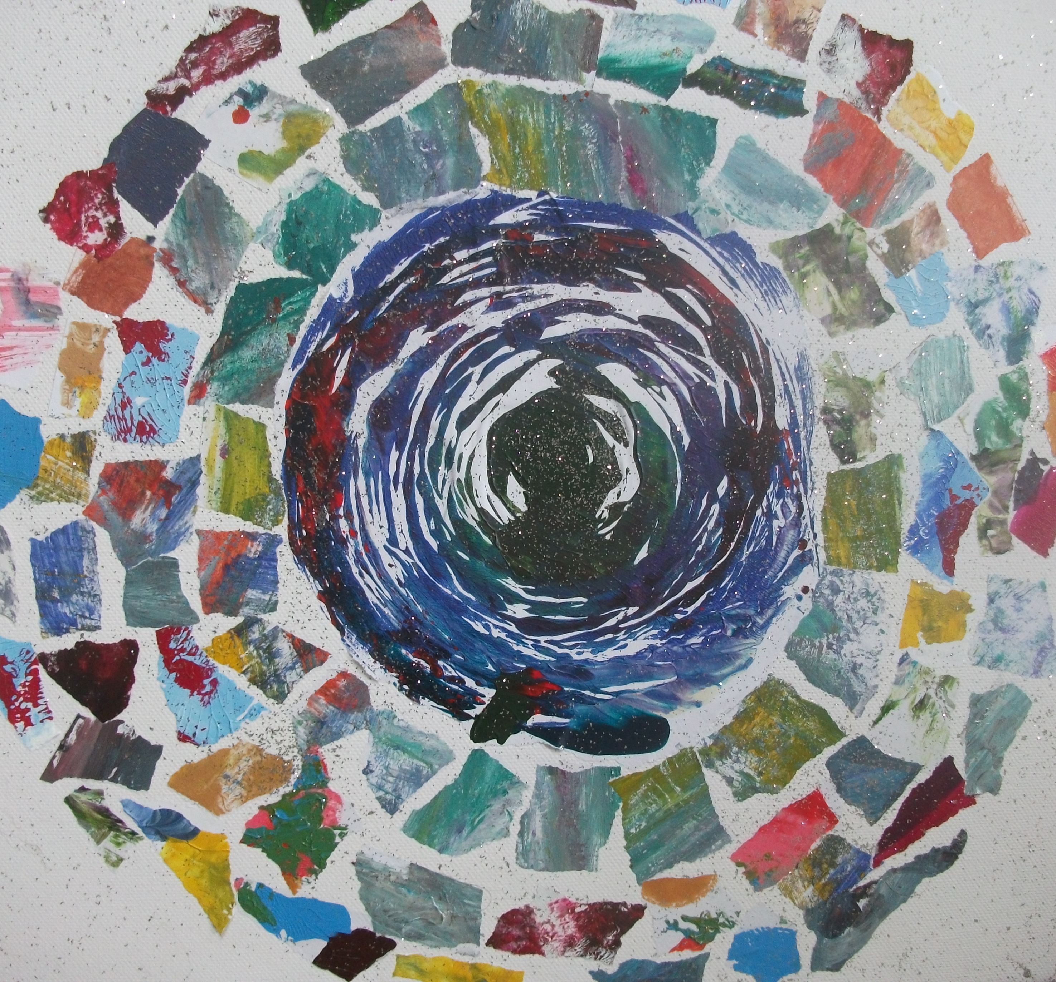
this whole top-down-bottom-up thing, asking why
we don’t just start from a totally different place?

inside-out (on one level) means going deeper
within ourselves: starting with intuition,
seeking our own unique ways of finding expression
for all that we have inside us, trying to burst its way out;
starting with all that has heart and meaning,
starting with who we are

inside-out (on another level) is meeting people
wherever they are: knowing development isn’t dropped
from a helicopter, nor does it bubble up
from underground springs, but it starts from within
the community… starting with layers of
local knowledge gleaned over time
from ancestors’ stories, and newly discovered
solutions found by the people who actually DO
this stuff, day in, day out

no arrows, then, but a spiral: no arrows pointing up
or down, but it starts with a spark
of our own inspiration, then spirals out
into one source of knowledge and then another, different
but equally valued... a dynamic dance of directionalities,
turning us all inside-out.
article #2 (starting from the inside) we recognize that if we ever want to promote `sustainable development’ we must learn to sustain and develop ourselves first

it sounds self-evident, even inane…
yet we know that our comfortable working spaces
are not (and never have been) designed
for truly sustaining our inner spark
or developing all that we love

we seek new spaces in which to explore
and express our deepest core in creative ways
not just with computers, coloured pencils and pens
but also with messy stuff: paint, clay, (whisper it) mud

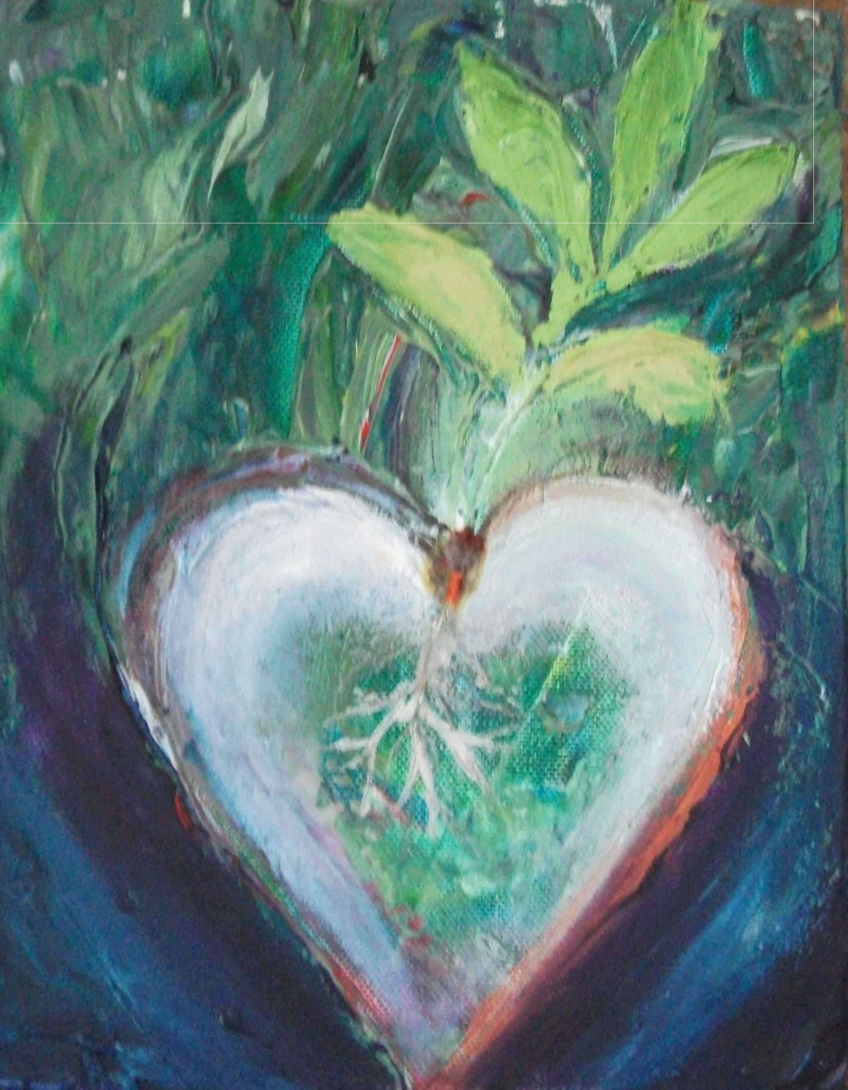
we seek new spaces in which to connect
in authentic ways with nature; where we can take our time
and learn from unspoken stories in other lives
that are lived out, unnoticed, around and within and beyond

we seek new spaces for sharing our wild ideas
and thrashing out challenging projects together:
why not circular paper, table-tops that revolve?

we seek new spaces to be alone, drawing our inspiration
from the all-encompassing vast unknowable
source of wisdom and hope

we seek new spaces in which to exhibit
the fruits of our soul(re)search:
not only in technical journals
that convert our quest into numbers
but in words and pictures and sounds
that touch lives and change people’s worlds

(in music, in dance and drama,
in visual arts, and the words intertwined with them all,
we find ways to express the ever-unsayable
incontrovertible truth
that we have not and cannot (and never will)
sustain anything whatsoever
or develop anything at all
until we develop the will to look
into our infinite hearts)
article #3 (venturing outside our comfort zone) we recognise that if we ever want to promote ‘sustainable development’ we must first learn how to sustain and develop our listening skills, and our ability to participate in true dialogues

listening to the forest should be the first lesson,
a courageous and radical act
that flies in the face of convention

we listen to the robin’s song
and the rustle of leaves, not as detached
observers of objects, but guests observed
by hosts in their homes: hearing their peer reviews
of our well-meant efforts, their plaintive questions
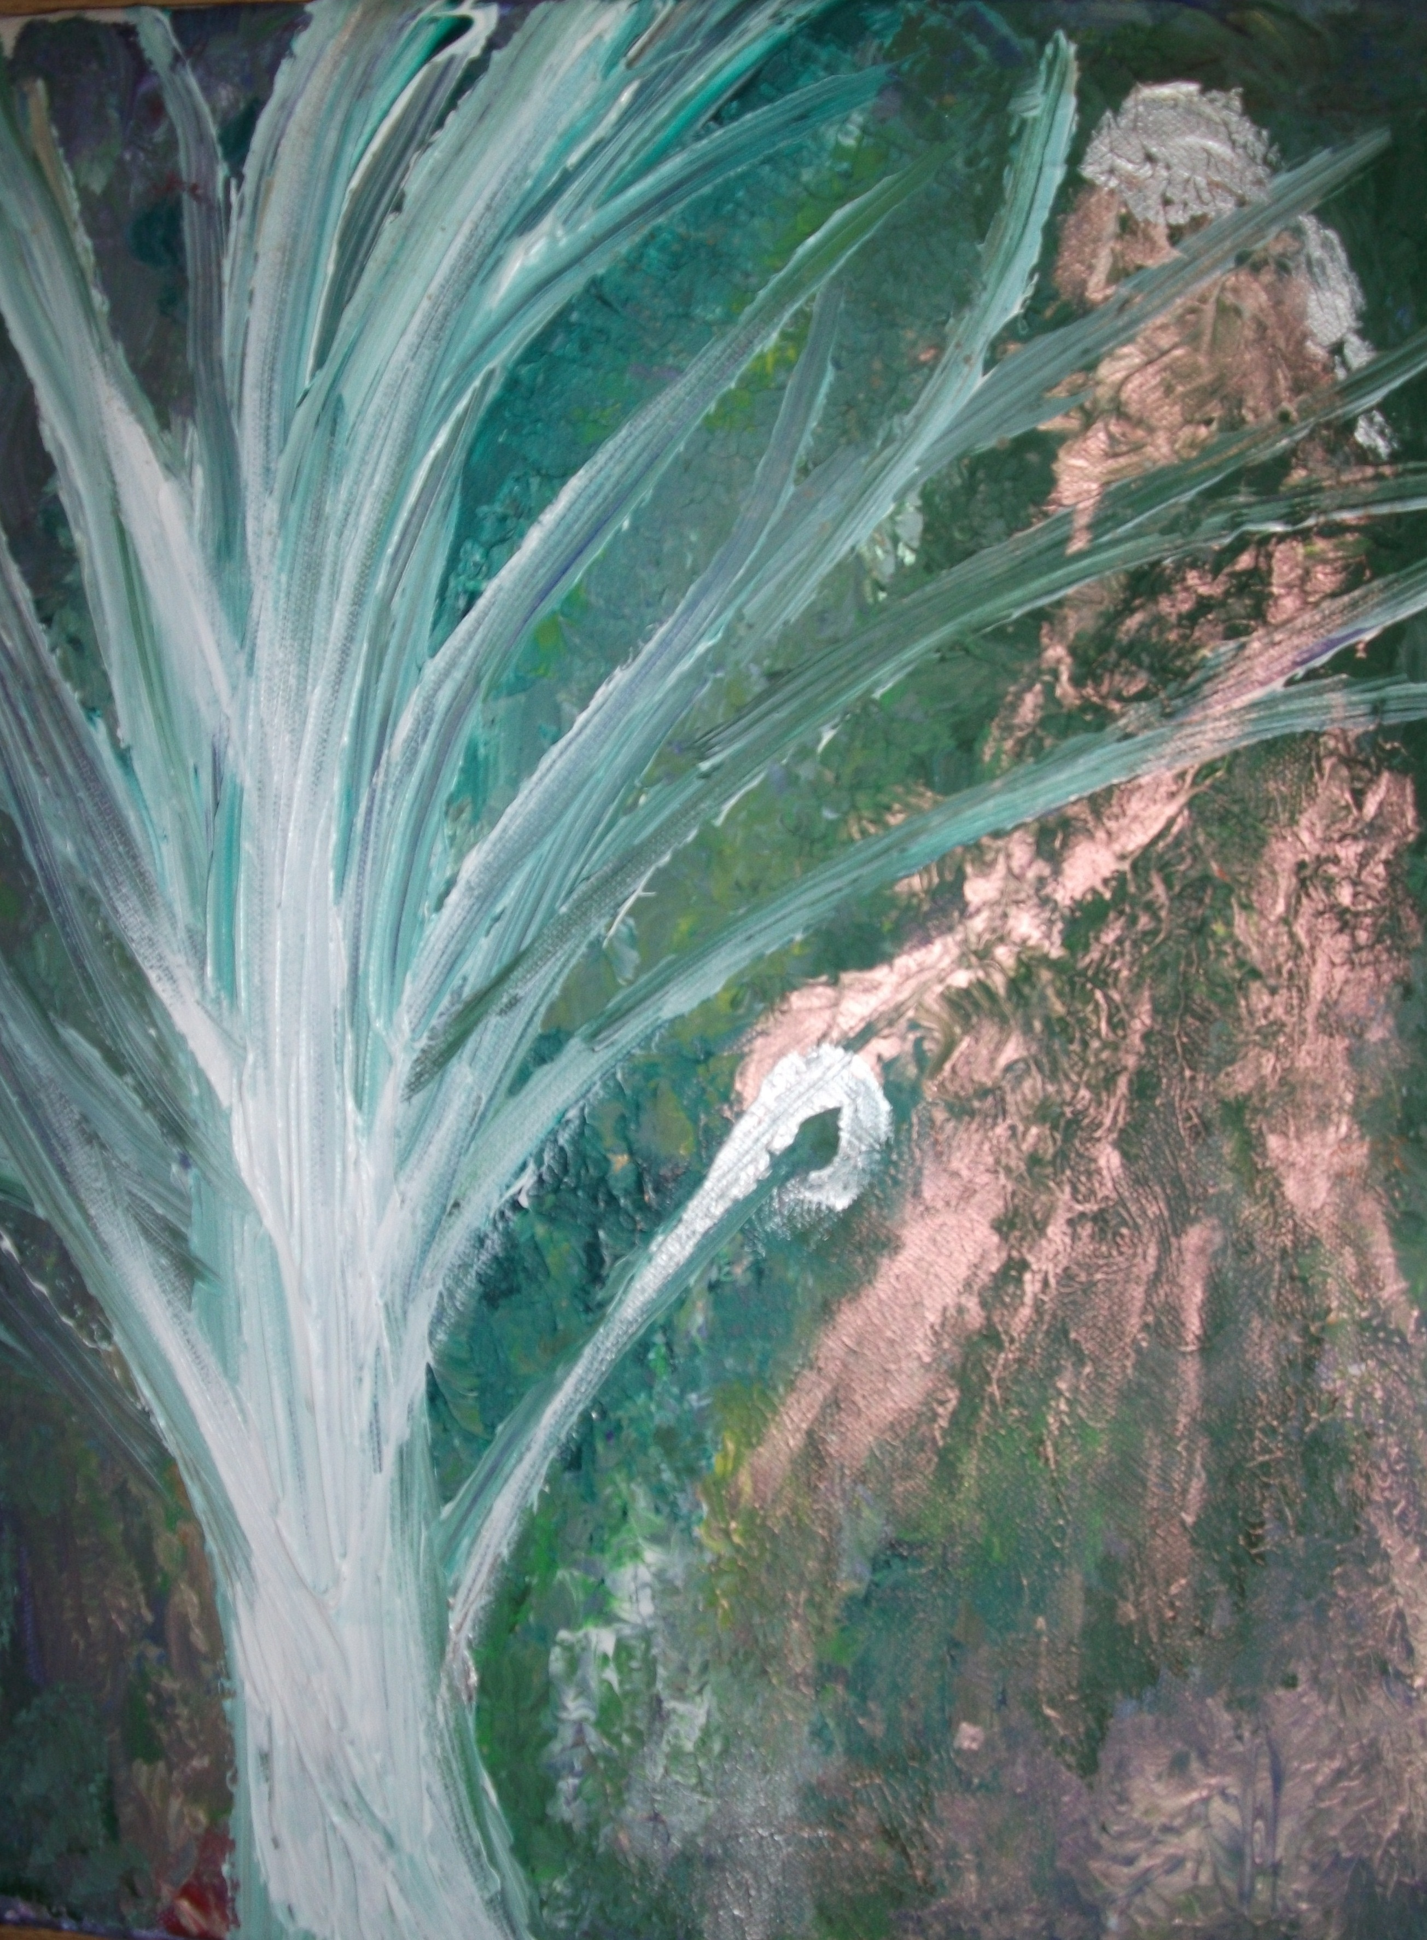
demanding responses, calling us (as so-called experts
who thought our truths self-evident) to revise and resubmit

we take the time to map out the known and unknown;
to hear the spoken, the sung and what is left unsaid;
to understand what is called for, with or without words,
to know what is being offered and to accept the gift

too many ‘dialogues’ are monologues in disguise:
pretending to listen, people only hear
what their brains are pre-programmed to hear, and speak
the words they already rehearsed. our manifesto
calls for a pause, a breath, a stepping-back
and switching off the auto-complete. radical enough
when we talk of other human beings; what, then, of the rest
of the biosphere, or the living earth itself?

the ancients knew that each river carries its tune,
each tree its rings of time, each flower its map
directing the bee to pollen, each stone its unique
vibration; but these are tongues that we never learned
to translate. we have to be free to be small
again: throw off our hard-won gowns
of expertise, and blow the seeds from a fluffy dandelion clock,
roll down a hill till we’re dizzy, giggle, spin
in spirals, sit by the fire, and listen. deeply listen
to each other, the stars, the night, and the spaces between;
and know even then we are only learners, not knowers:
all that we are, and all we profess, is always incomplete.

article #4: we reject dichotomies and `either/or’ thinking, and recognise that the world is far more complex than we ever imagined: we CAN have both, or neither, or something in between

we design for, through and with the sustaining of hope,
employing both art and science, both heart and head,
both body and soul, both reason and intuition,
both knowledge and wisdom, both dreamscapes and conscious thought

we contest gay-straight, male-female, inside-or-out,
we refuse to reduce any issue to black-and-white:
loving not only the shades of grey, but the full spectrum
of colours (infrared, ultraviolet, we never discriminate;
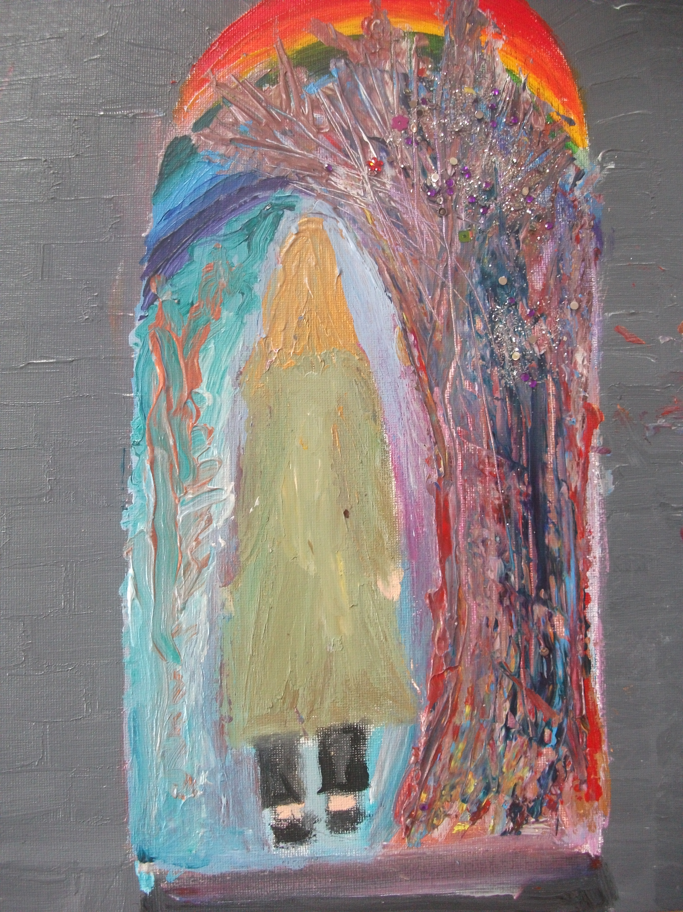
the small matter of not being visible isn’t a problem
for us). we are the rainbow people, dancing in
liminal spaces, stepping out from the dusty shadows of
ancient tomes and into the fullness of life. we are
(re)searching in novel ways, rewriting the books,
juggling multiple hats and dropping them all on the floor

we honour complexities, nuances, conflicts, paradox, tensions,
unanswered questions, unsolved riddles, the whole messy
untheorisable inexplicable business of everyday chaos

let someone into your heart and they’ll probably break it;
let people into your neatly ordered framework
and it’s never the same again; but in work, as in love,
the theory goes out the window. we are participated,
stretched out in all directions, forced to rethink
all that we thought we knew, and rethink it again
and again and again, until someone grudgingly says
that they think we might be getting the point at last

we draw no lines between `life’ and work, using both
as spaces for exploration, crazy creation, cups of tea
with friends that we trust. we find in each other’s ideas
reflections of something we almost dared to think
last Thursday afternoon, before the mobile rang.
within the authentic relationships, we learn to create as one,
drawing on all of each other’s strengths
and all of our personal power

#5: we are bold in both our vision and our practical activism, daring to think beyond the limits of what is currently recognised as ‘possible’

we take nothing as given; we take nothing for granted
we acknowledge constraints, but are always thinking up ways
to work around and beyond them. we dream a big dream,
and take a small step; then another, another, another.

if we know we can’t fully become the change
that we wanted to see in the world,
at least we become the beginning.
we _______________________
______________________________________________
______________________________________________________
__________________________________________________
____________________________________________
_______________________________________________________
(we fill in the gaps ourselves) and we know that the time
will never get any better
or the place be any more suitable
than right-here-right-now

and I mean
right
now

References

Abram, D. The spell of the sensuous: perception and language in a more-than-human world. 1996, New York: Vintage Books.
Arrien, A. The four-fold way: walking the paths of the warrior, teacher, healer and visionary. 1993. San Francisco, CA: HarperSanFrancisco.
Becker, H. S. Art worlds. 1982, Berkeley: University of California Press.
Bergman, D. Sustainable design: a crtiical guide. 2012, New York: Princeton Architectural Press.
Blizzard, J. L. and Klotz, L. E. (2012). A framework for sustainable whole systems design. Design Studies 33: 456-479.
Buchanan, R., Wicked problems in design thinking, in The Idea of Design, V. Margolin and R. Buchanan, Editors. 1995, The MIT Press: Cambridge, MA. p. 14.
Burgess, H. Hawai'i, in We are one: A celebration of tribal peoples. J. Eede, Editor, 2009. London: Quadrille Publishing Ltd., p. 33.
Cherokee Statement. USA, in We are one: A celebration of tribal peoples. J. Eede, Editor, 2009. London: Quadrille Publishing Ltd., p. 26.
Ferguson, J., The anti-politics machine: “development”, depoliticization, and bureaucratic power in Lesotho. 1994, Minneapolis: University of Minnesota Press.
Frasera, E. D. G., Dougill, A. J., Mabee, W. E., Reed, M., and McAlpine, P. Bottom up and top down: Analysis of participatory processes for sustainability indicator identification as a pathway to community empowerment and sustainable environmental management. Journal of Environmental Management, 2006. 78: 114-127.
Fuad-Luke, A., Design activism: beautiful strangeness for a sustainable world. 2009, London: Earthscan.
Gablik, S. The reenchantment of art. 1991, London: Thames and Hudson.
Gallhofer, S., et al. Developing environmental accounting: insights from indigenous cultures. Accounting, Auditing and Accountability Journal, 2000. 13(3): 381-409
Grainger, A., Forest sustainability indicator systems as procedural policy tools in global environmental governance. Global Environmental Change, 2012. 22: 147-160.
Hodgson, D. Being Maasai, becoming indigenous: postcolonial politics in a neoliberal world. 2011, Bloomington, IA, USA: Indiana University Press..
Kagan, S. Art and sustainability: connecting patterns for a culture of complexity, 2nd edition. 2013. Bielefeld: Transcript Verlag.
Kaufman, F. The end of sustainability. International Journal of Sustainable Society, 2009. 1(4): 383-390.
Kopenawa, D. Yanomami, Brazil, in We are one: A celebration of tribal peoples. J. Eede, Editor, 2009. London: Quadrille Publishing Ltd., p. 138.
McCool, S.F., and Stankey, G. H. Indicators of sustainability: challenges and opportunities at the interface of science and policy. Environmental Management, 2004. 33(3): 294–305.
McDonough, W., Braungart, M., et al. Peer reviewed: Applying the principles of green engineering to cradle-to-cradle design. Environmental Science and Technology, 2003. 37(23): 434A-441A.
McLennan, J. F. The philosophy of sustainable design: The future of architecture. 2004. Kansas City, Missouri, Ecotone Publishing.
Melles, G., de Vere, I., et al. Socially responsible design: thinking beyond the triple bottom line to socially responsive and sustainable product design. CoDesign: International Journal of CoCreation in Design and the Arts, 2011, 7(3-4): 143-154.
Momin, A. R. The facade of objectivity - an inquiry into the epistemology of value-free sociology. 1972. Economic and Political Weekly, 7(44): 2195-2202.
Nqate. Bushman, Botswana, in We are one: A celebration of tribal peoples. J. Eede, Editor, 2009. London: Quadrille Publishing Ltd., 46.
Orr, J. A. Learning from Native adult education. 2000. New Directions for Adult and Continuing Education, 85: 59-66.
Papanek, V. The green imperative: natural design for the real world. 1995. New York: Thames and Hudson.
Plotkin, B. Nature and the human soul: cultivating wholeness in a fragmented world. 2008. Novato, CA: New World Library.
Reed, M. S., Fraser, E. D. G., and Dougill, A. An adaptive learning process for developing and applying sustainability indicators with local communities. Ecological Economics 2006. 59: 406-418.
Reitan, J. Inuit vernacular design as a community of practice for learning. CoDesign: International Journal of CoCreation in Design and the Arts 2006. 2(2): 71-80.
Robinson, J. Squaring the circle? Some thoughts on the idea of sustainable development. Ecological Economics 2004. 48: 369-384.
Steen, M. Human-centered design as a fragile encounter. Design Issues, 2012. 28(1): 72-80.
Sterling, S. Sustainable education: re-visioning learning and change. 2001, London, UK: Green Books.
Stewart-Harawira, M. Cultural studies, indigenous knowledge and pedagogies of hope. Policy Futures in Education, 2005, 3(2): 153-163.
Stirling, A., Leach, M., and Scoones, I., Editors. Dynamic sustainabilities: technology, environment, social justice. 2010, Abingdon, UK: Earthscan.
Walker, S. Sustainable by design: explorations in theory and practice. 2006. London, UK: Earthscan.
Walker, S. Design redux, in Designers, visionaries and other stories, J. Chapman and N. Gant, Editors, 2007. London: Earthscan, 61.
Wang, S., Wicked problems and metaforestry: is the era of management over? Forestry Chronicle 2002. 78: 505-510.
Williams, L., Roberts, R., et al. Introduction: Human ecology: a pedagogy of hope? In Radical human ecology: indigenous and intercultural approaches. L. Williams, R. Roberts and A. McIntosh. 2012, Farnham, Surrey: Ashgate, 1-14.
Winschiers-Theophilus, H., Bidwell, N. J., and Blake, E. Community consensus: design beyond participation. Design Issues 2012. 28(3): 89-100.
Zapf, M. K. The spiritual dimension of person and environment: perspectives from social work and traditional knowledge. International Social Work 2005. 48(5): 633-642.

Biographical Note
G. Burford is a researcher, designer and artivist based in the Values and Sustainability Research Group at the University of Brighton. Research focuses on the roles of values and values-based indicators in project co-design and participatory evaluation, and she has made both artistic and academic contributions to AHRC-funded collaborative research projects, as well as teaching Sustainable Development. He is also the founder and CEO of Green Spiral Arts, an arts-centred personal and organisational development consultancy, and has previously worked in Tanzania as a designer of intercultural education curricula and innovative grassroots projects. He was awarded the first CASIC Working Paper Series Award at the International Summit on 15th October, 2015 and can be contacted on ash@t-lis.org

Notes

Indigenous’ is a highly contested category, used in some circles to refer to geographical origins (the ‘first people’ in a given territory) and in others to describe people with distinctive cultural identities and/or livelihood strategies that are marginalized by mainstream societies Hodgson, D. (2011). Being Maasai, becoming indigenous: postcolonial politics in a neoliberal world. Bloomington, IA, USA, Indiana University Press.. More recently, Lewis Williams and colleagues Williams, L., R. Roberts, et al. (2012). Introduction: Human ecology: a pedagogy of hope? . Radical human ecology: indigenous and intercultural approaches. L. Williams, R. Roberts and A. McIntosh. Farnham, Surrey, Ashgate: 1-14. have redefined the term ‘indigenous’ as neither a political nor a cultural category, but as a mindset of `deep interconnectedness’ that embraces everyone and can be shared by anyone. It is in this latter, more inclusive sense that we use the word within this book, even while acknowledging controversies around Indigenous identities and self-determination struggles.
Acknowledgement is already due to Julian Brigstocke of the Authority Research Network for his helpful critique, which inspired me to make a small change to Article 1. I had originally made an ironic comment ‘bottom-up is so last decade: the future is inside-out’. However, as Brigstocke noted, this could easily have been misinterpreted and taken at face value, implying a discourse of `progress’ that risked undermining the overall message of the manifesto. In the current version, I have replaced this line with the “dynamic dance of directionalities”, aiming to highlight that ‘inside-out’ is just one perspective among many.

